

**SCOPE**

FALL SEMESTER 2025-2026

# **LAB ASSESSMENT -1**

**Slot:** L13+L14

**Class**: VL2025260105679

**Programme Name & Branch:** B. Tech CSBS

**Course code & Title**: CBS3005- CLOUD, MICROSERVICES AND APPLICATIONS LAB BASED COMPONENTS

**Faculty Name**: NITHYA K

**SUBMITTED BY: -**DIPANGSHU KUNDU

**REGISTRATION NUMBER**: -22BBS0148

**QUESTION 1:**

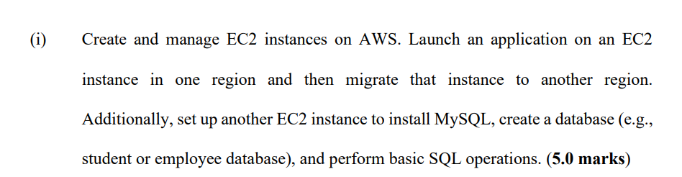

**SOLUTION: -**

1. **ACCOUNT CREATION**

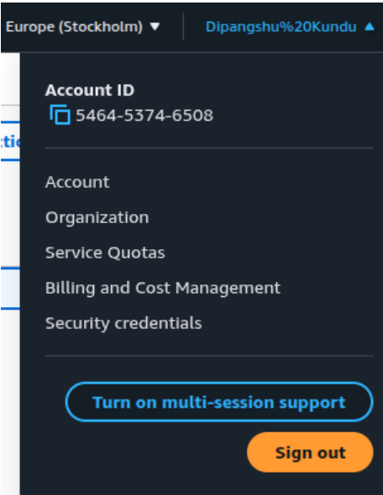

1. **AWS EC2 INSTANCE**

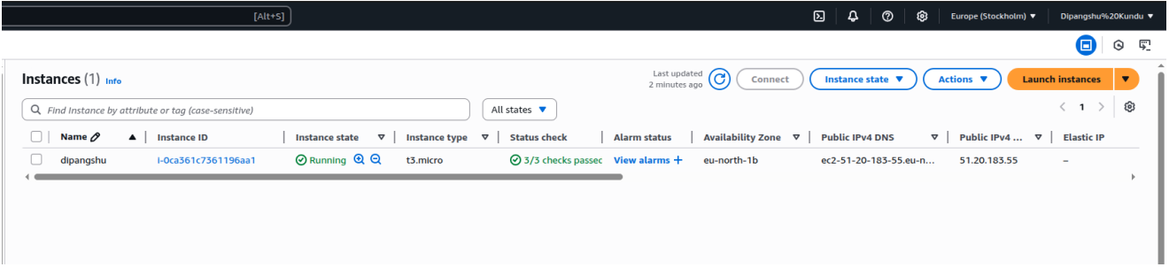

1. **AWS EC2 INSTANCE MY SQL SERVER**

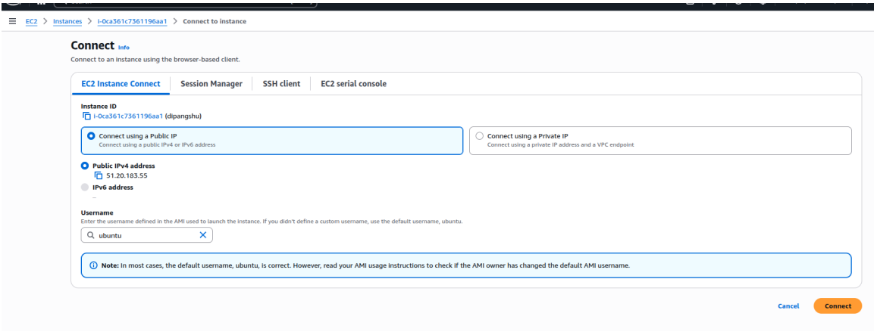

1. **STEPS TO CONNECT MYSQL**

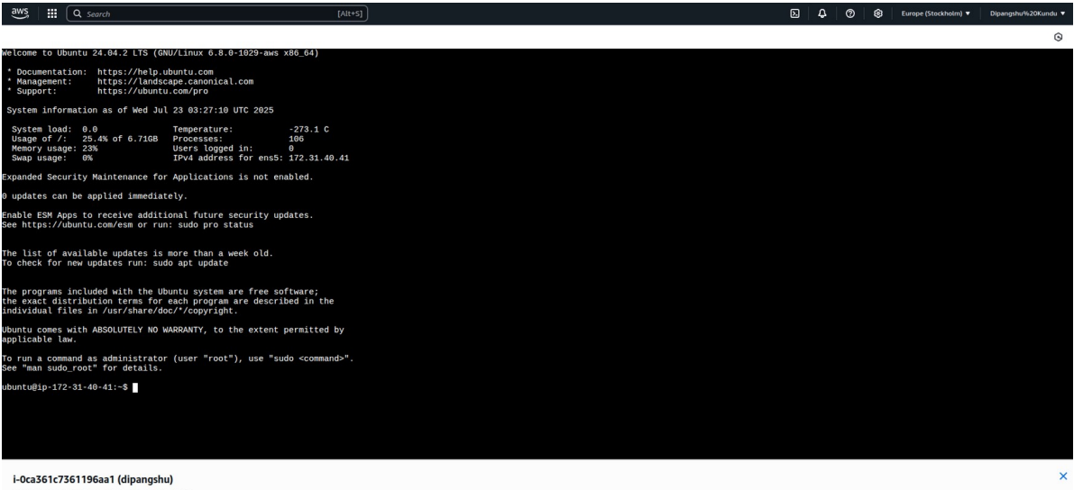

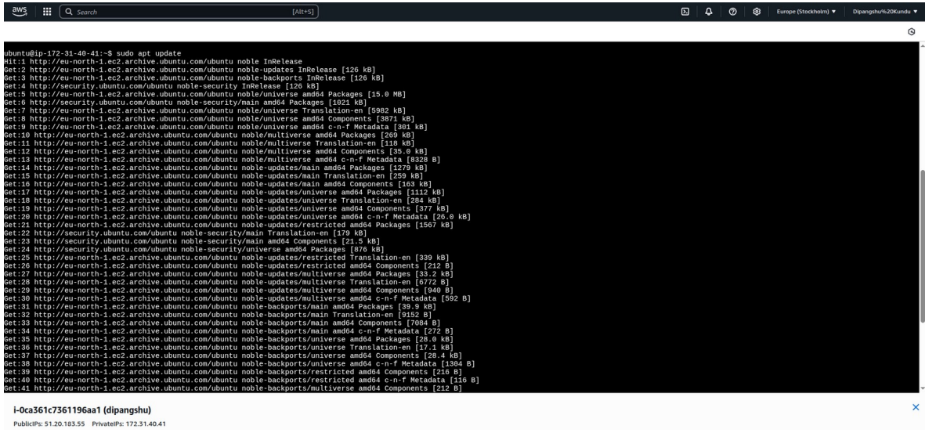

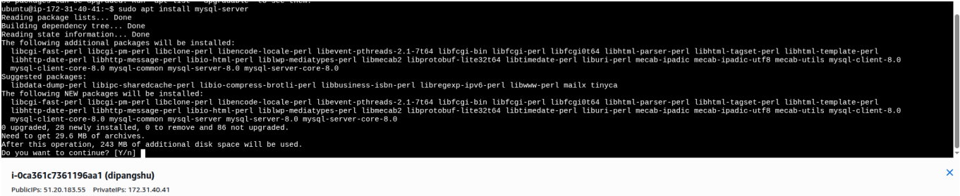

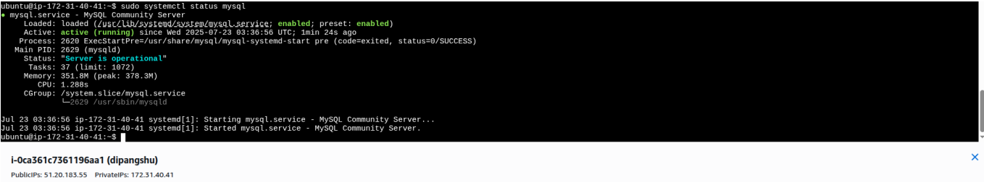

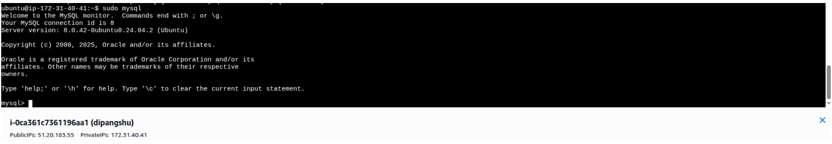





**BASIC SQL OPEATIONS:**

**CREATING DATABASE**

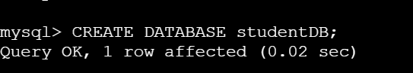

**USING DATABASE:**

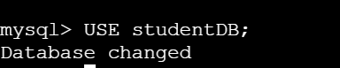

**CREATING TABLE STUDENTS:**

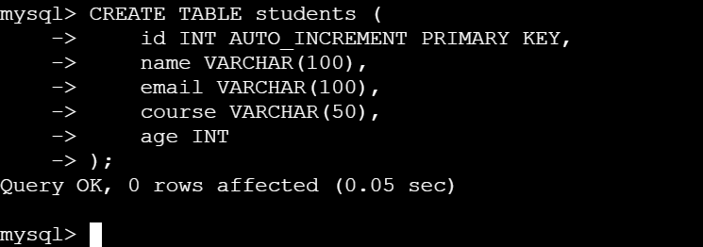

**INSERT OPERATION:**

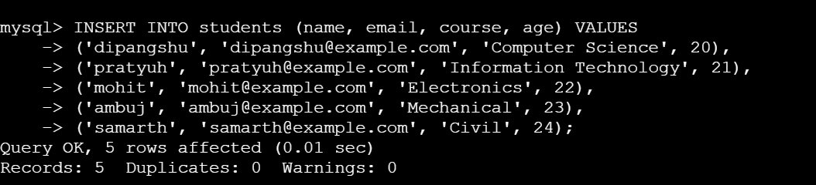

**SELECT OPERATION:**

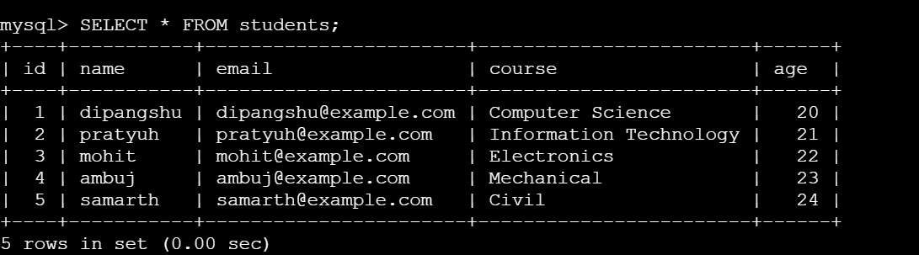

**SELECT OPERATION WITH ‘WHERE’ CLAUSE:**

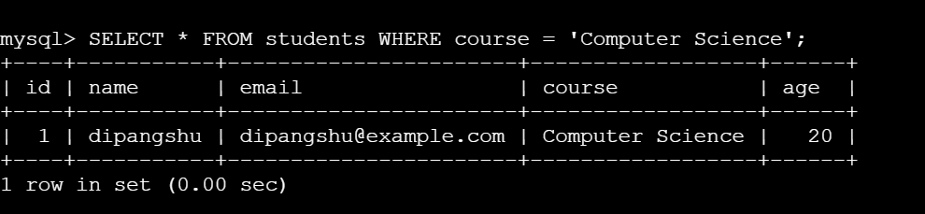

**UPDATE OPERATION:**

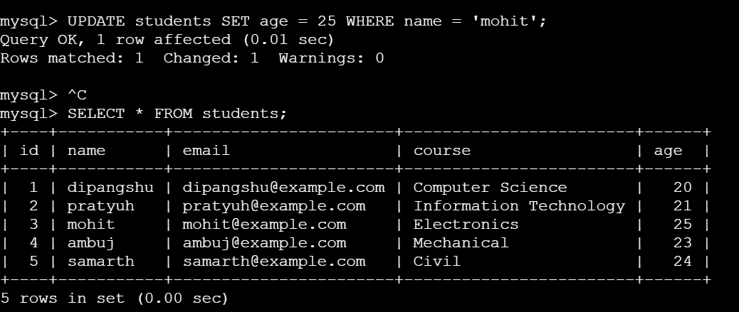

**DELETE OPERATION:**

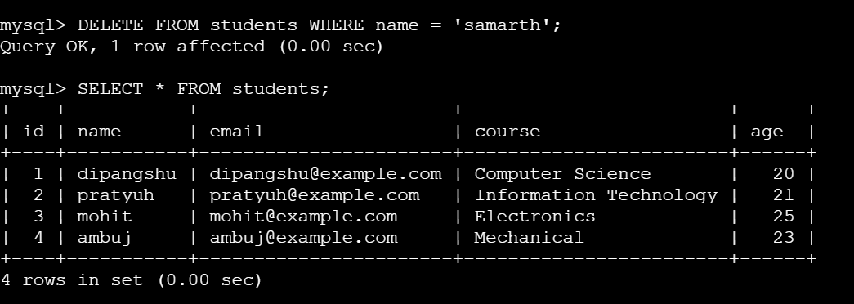

**LAUNCHING A STATIC WEBSITE USING EC2 INSTANCE:**

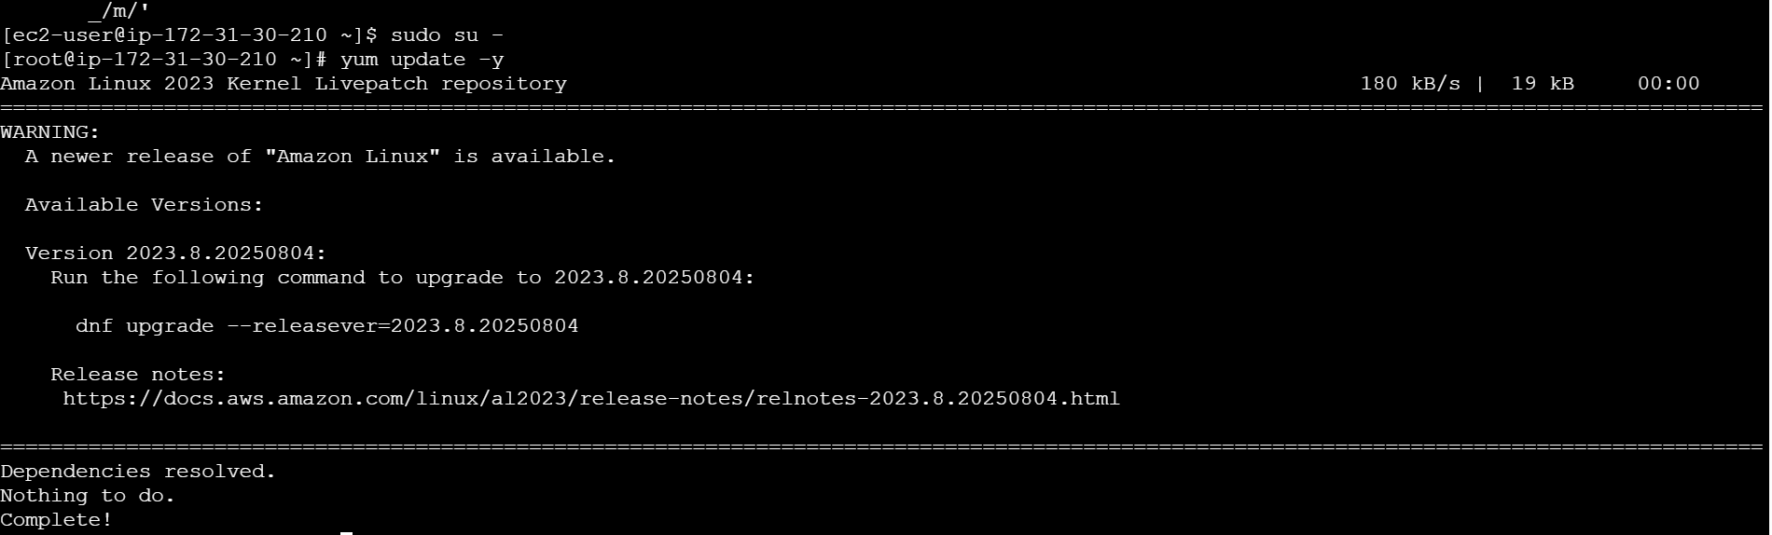

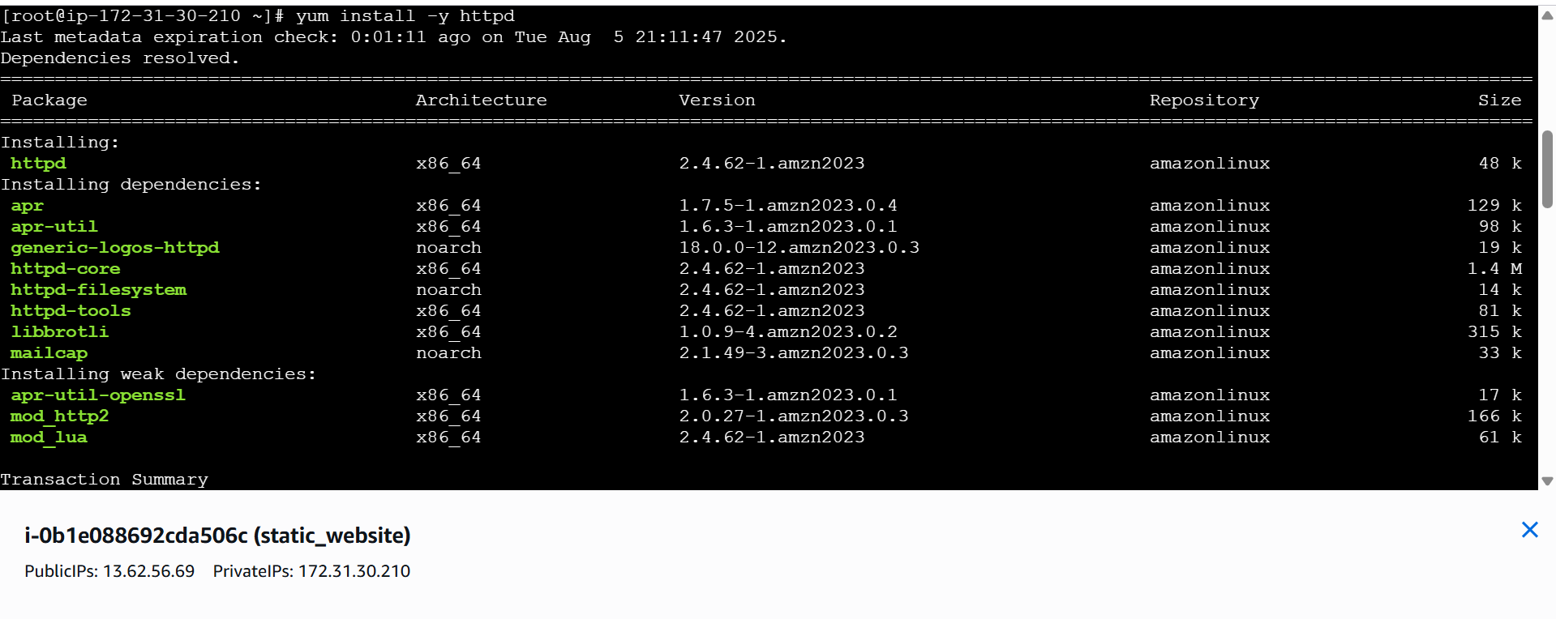

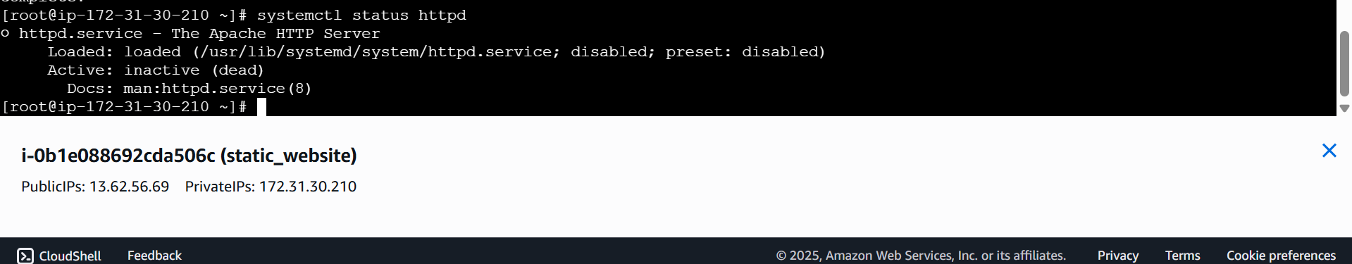

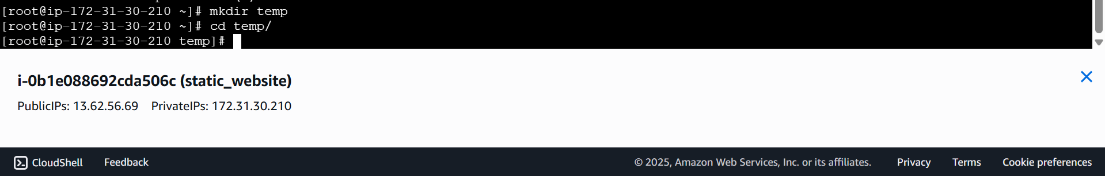

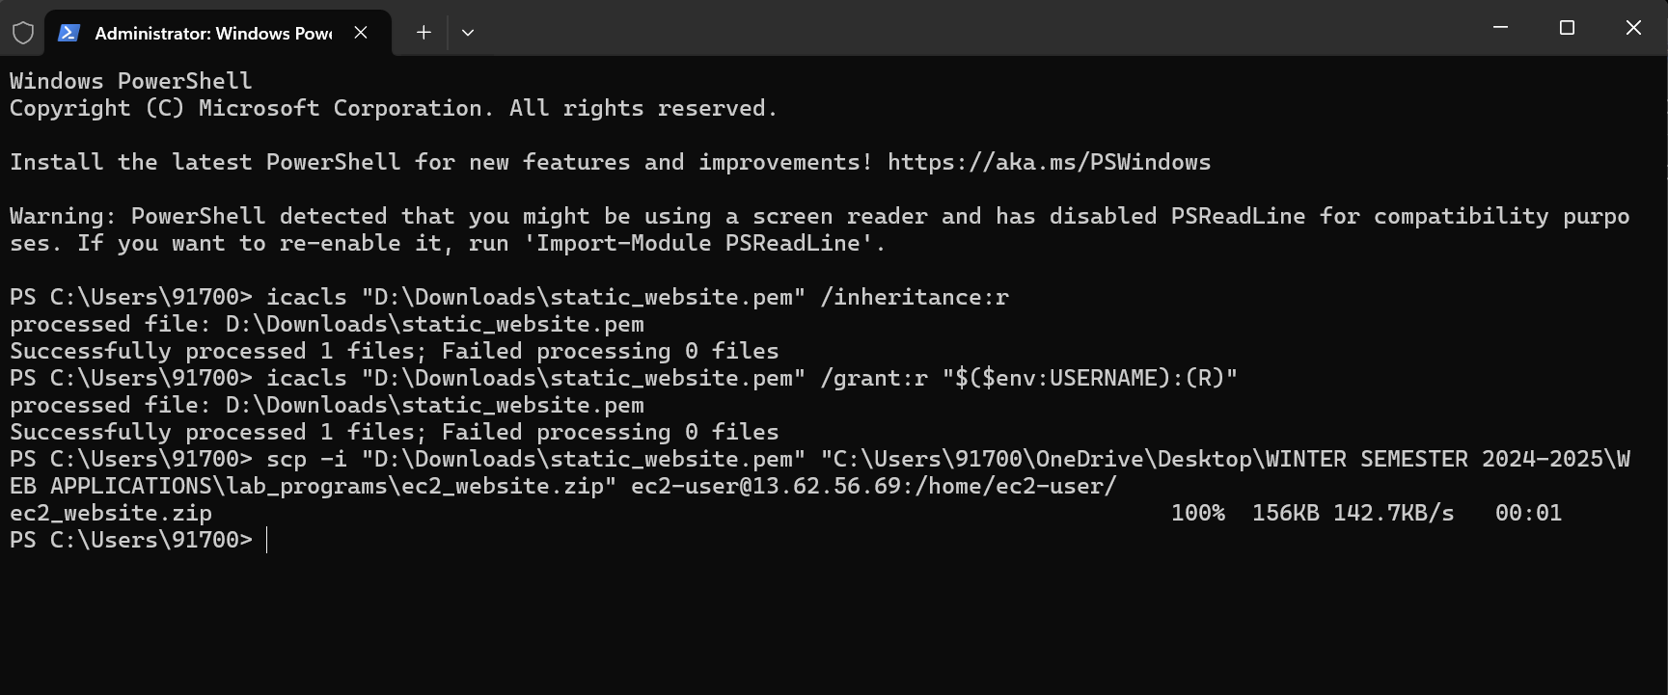

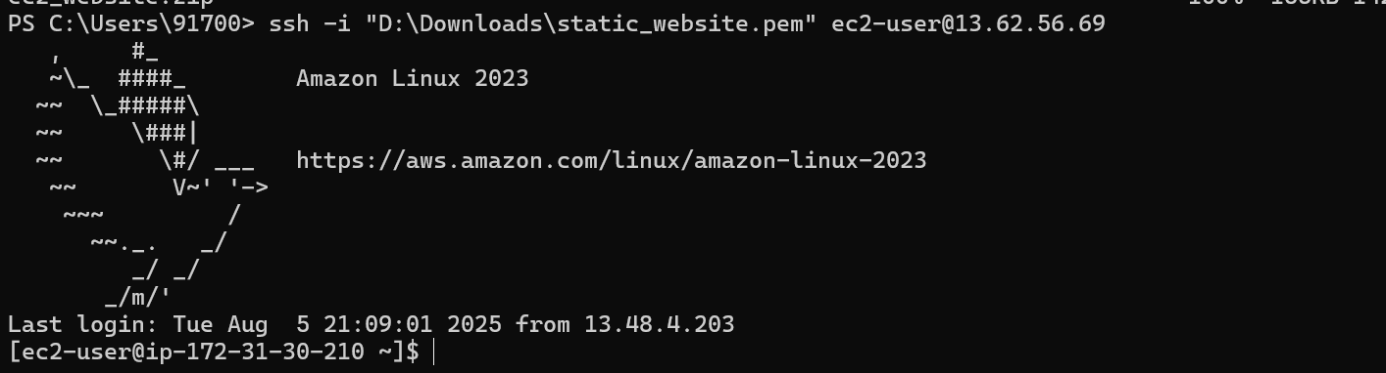

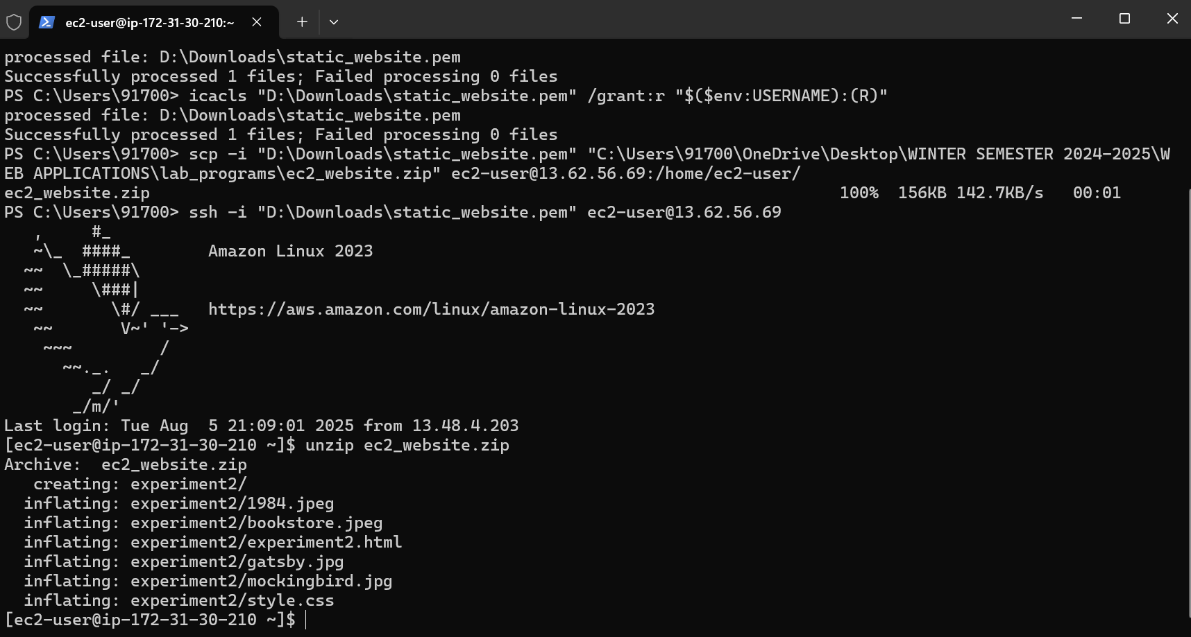

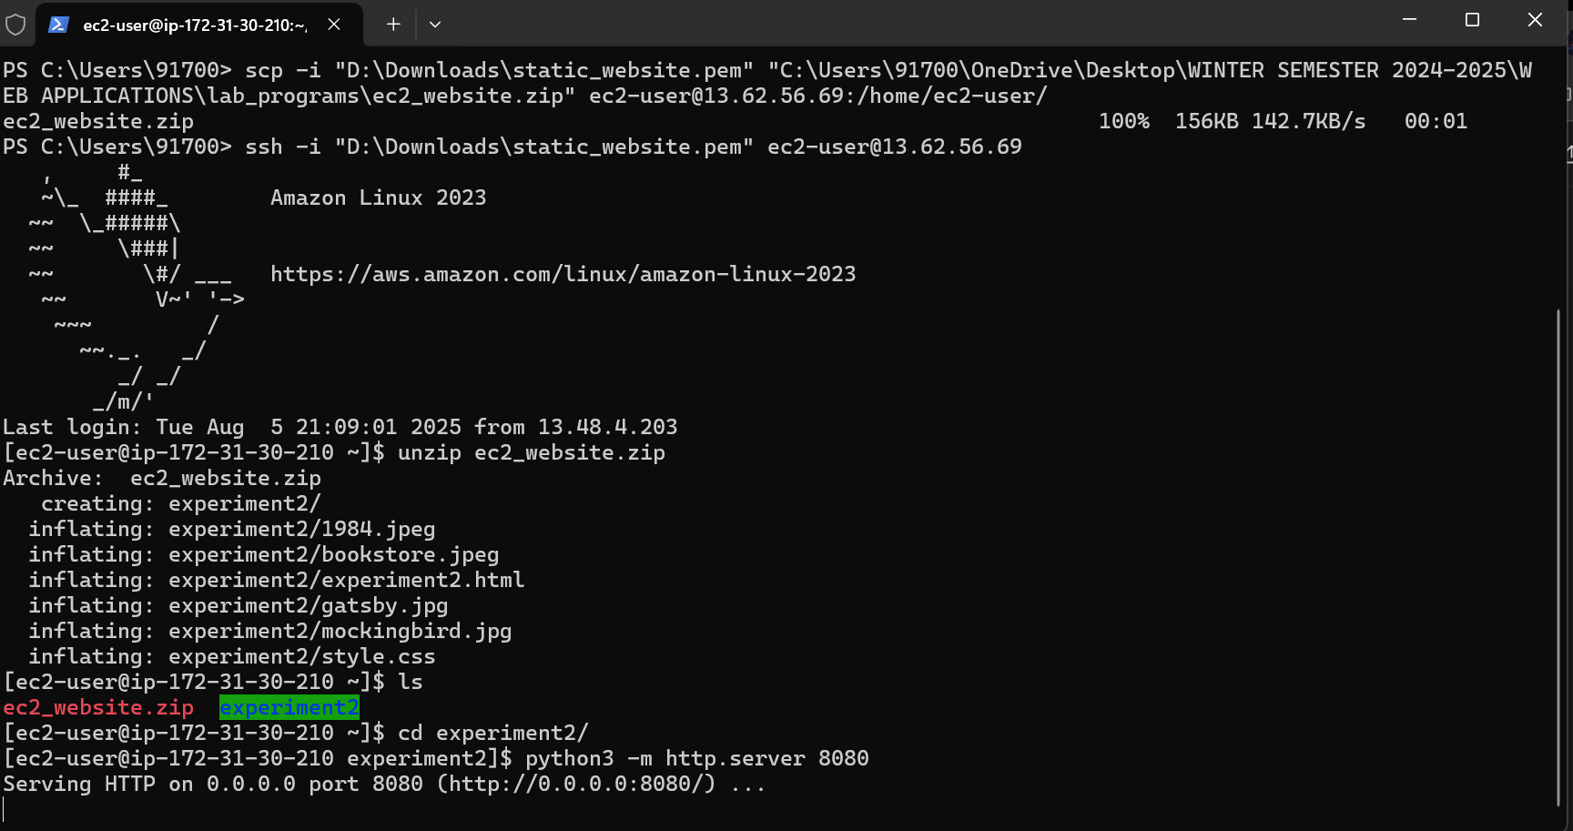

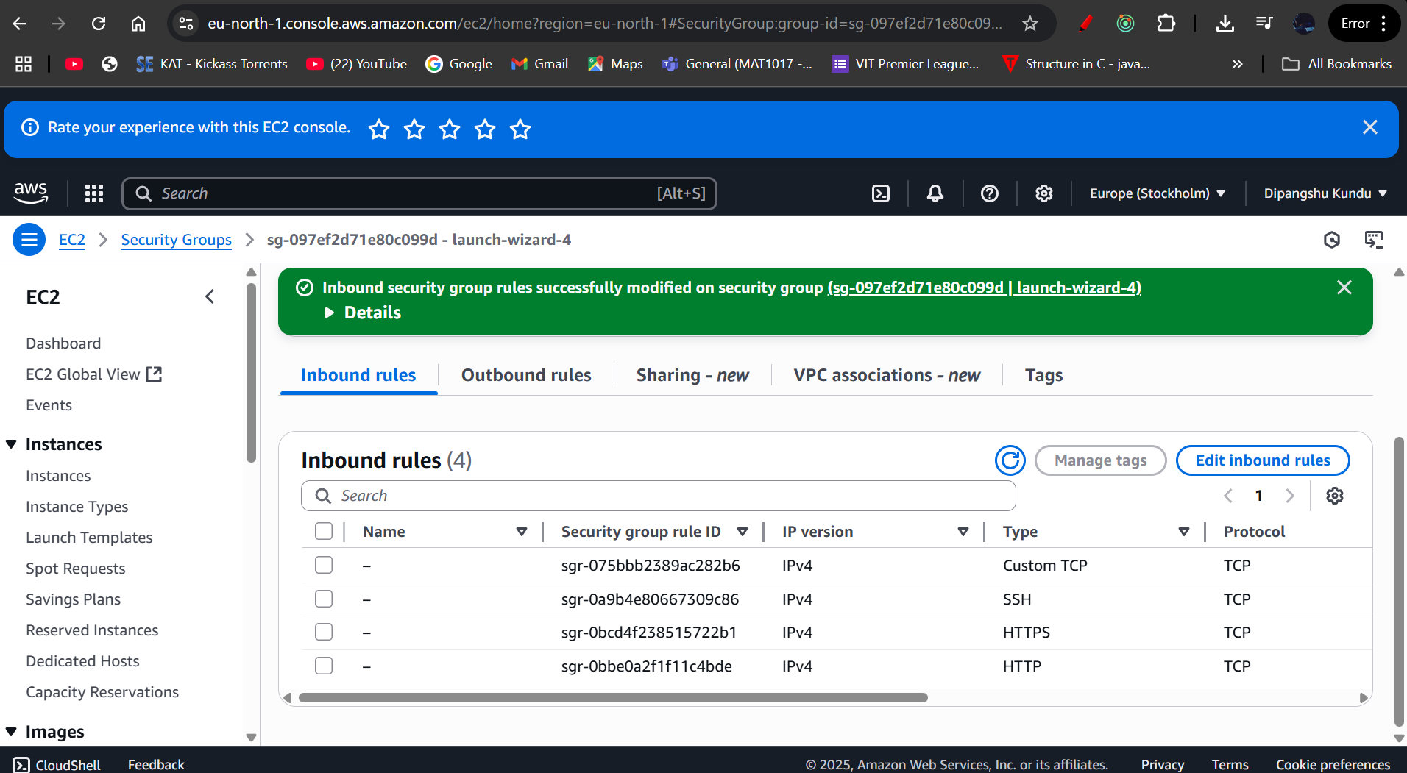

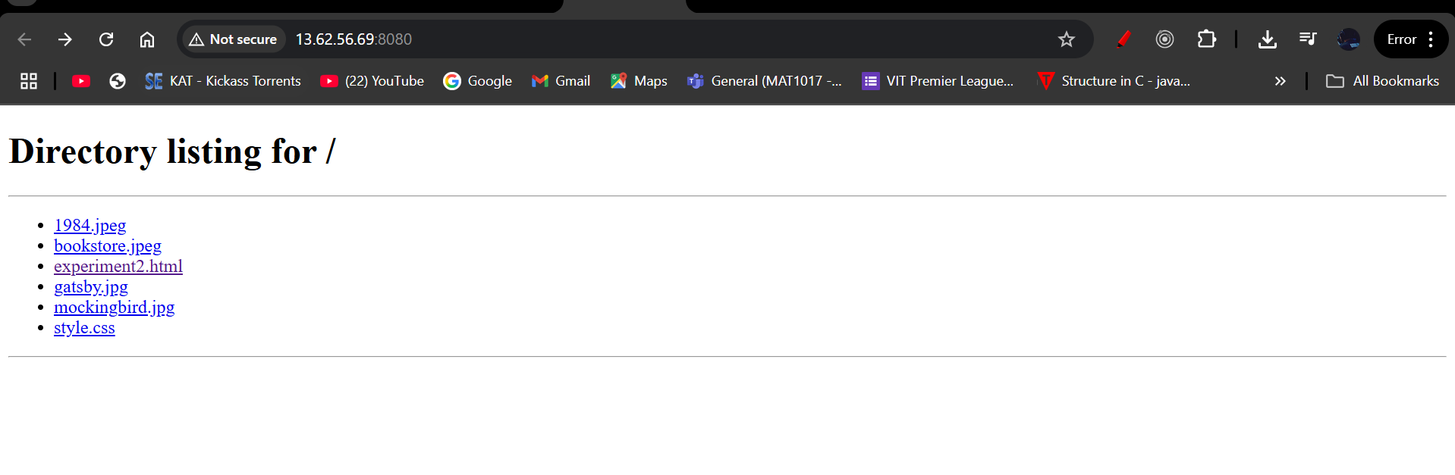

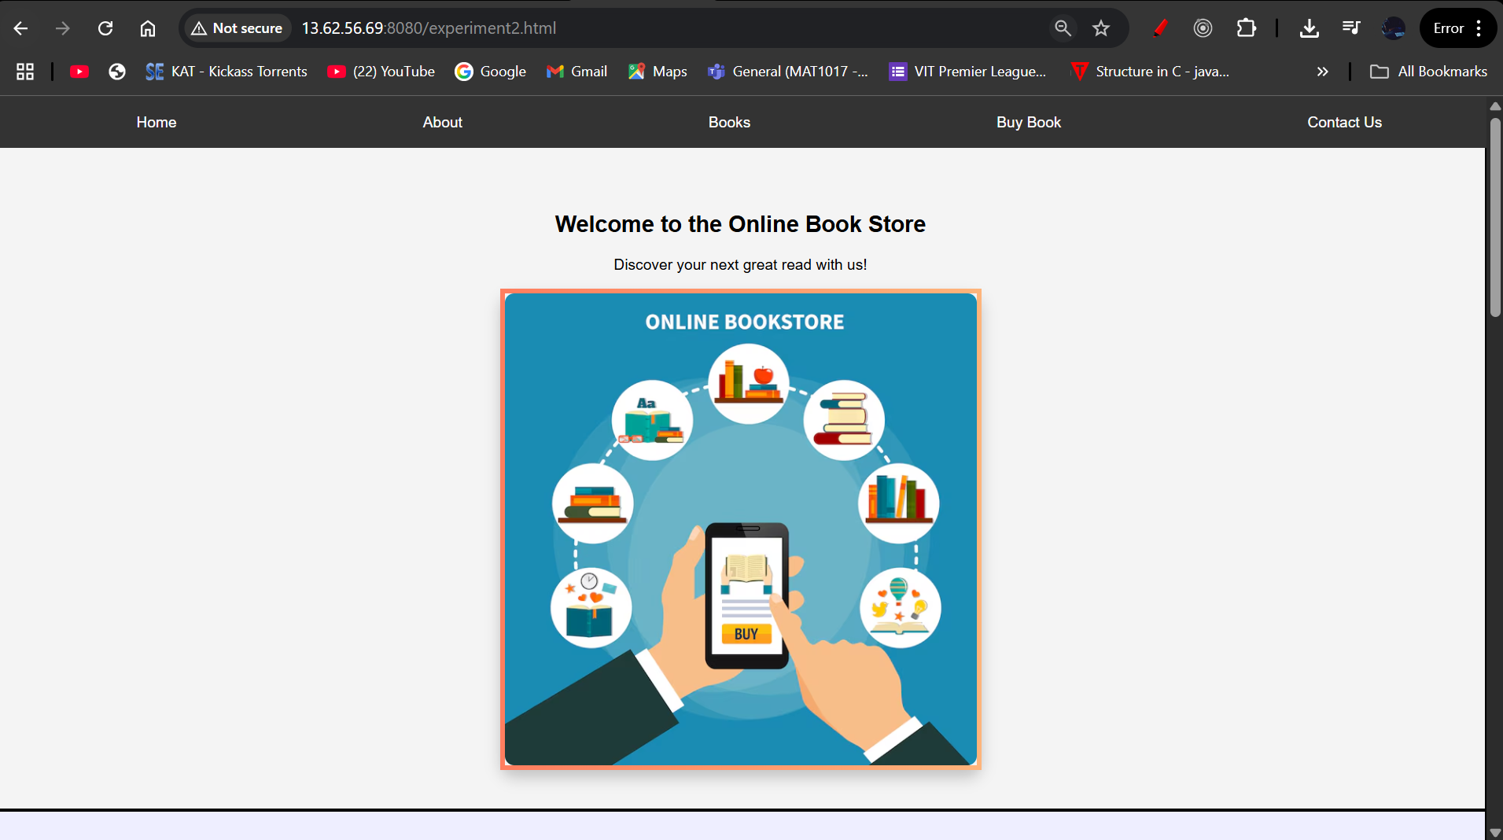

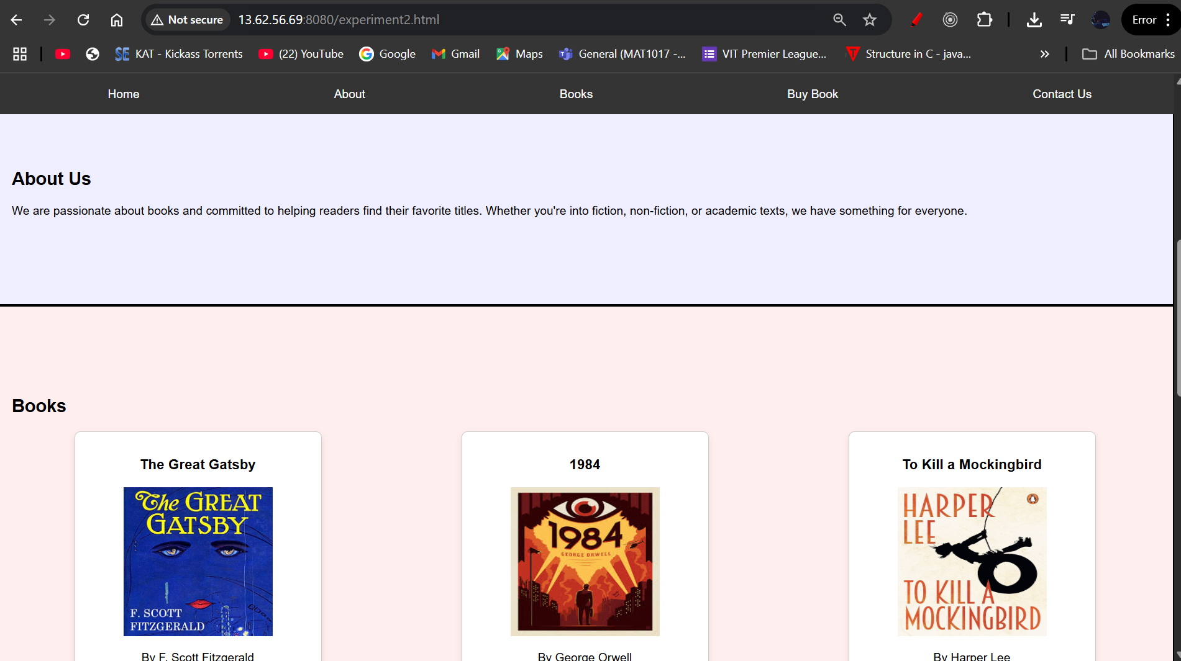

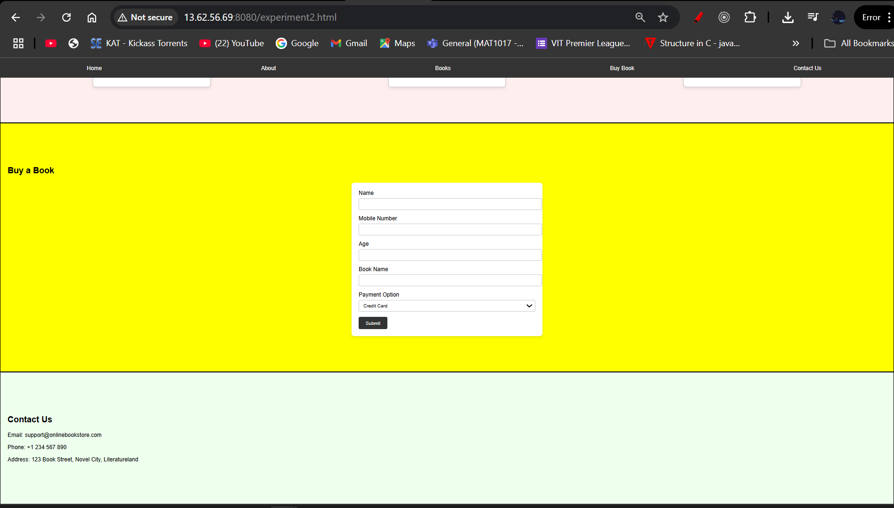

**MIGRATION OF EC2 INSTANCE FROM ONE REGION TO ANOTHER REGION:**

**CURRENT REGION:**

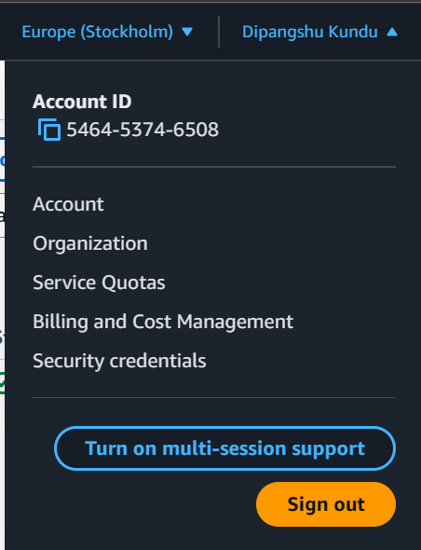

**STEPS TO BE FOLLOWED:**

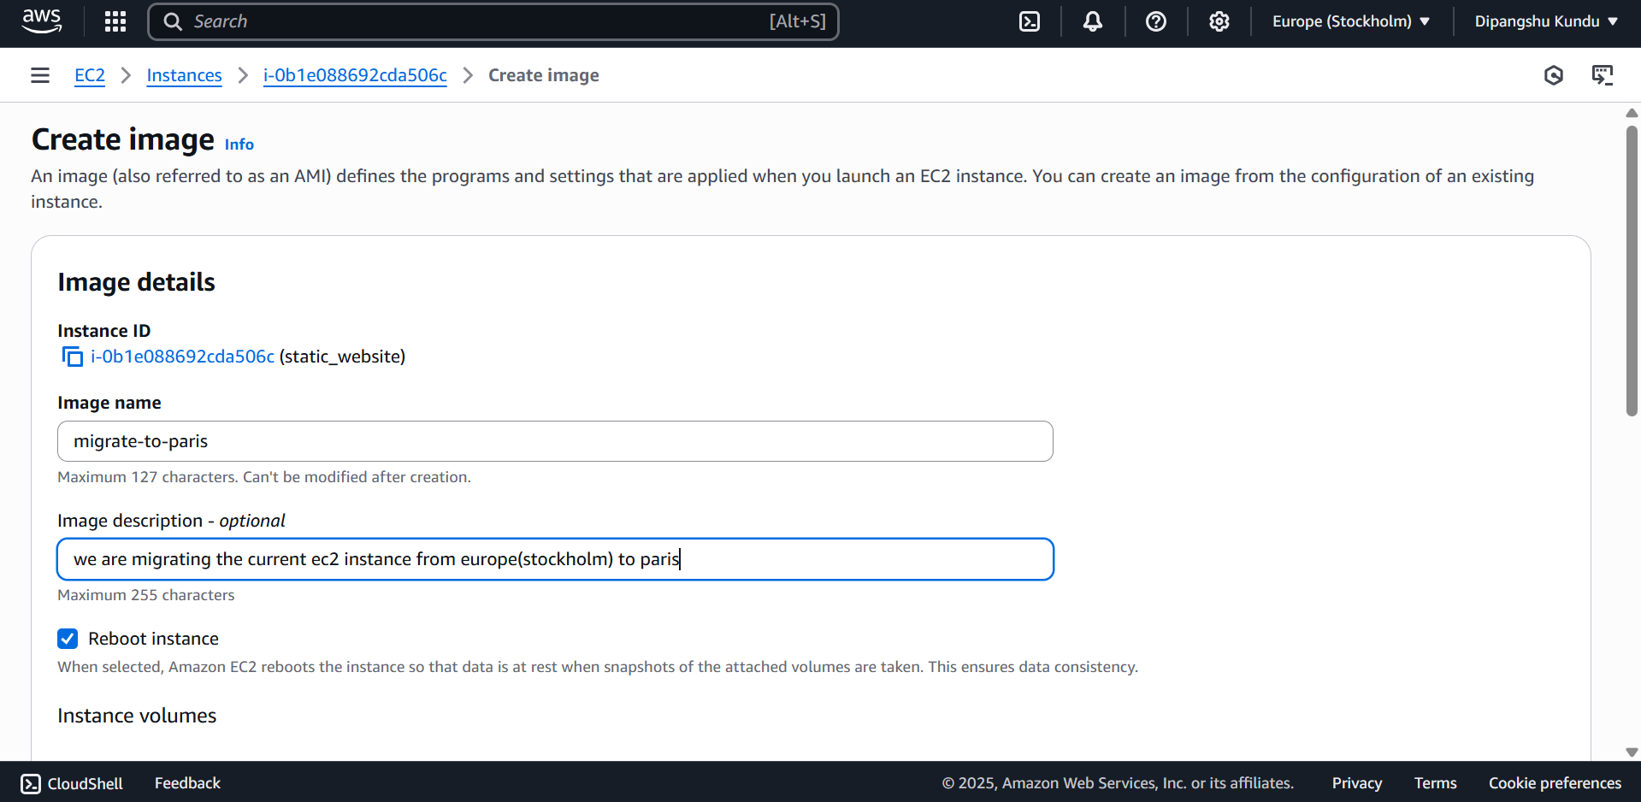

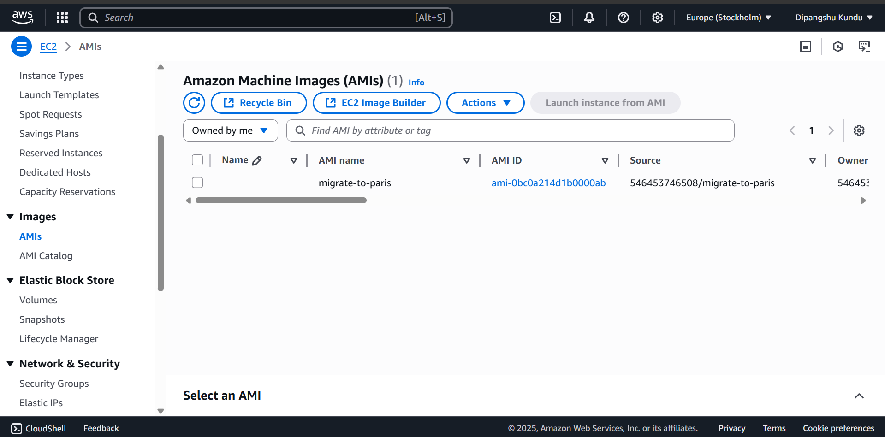

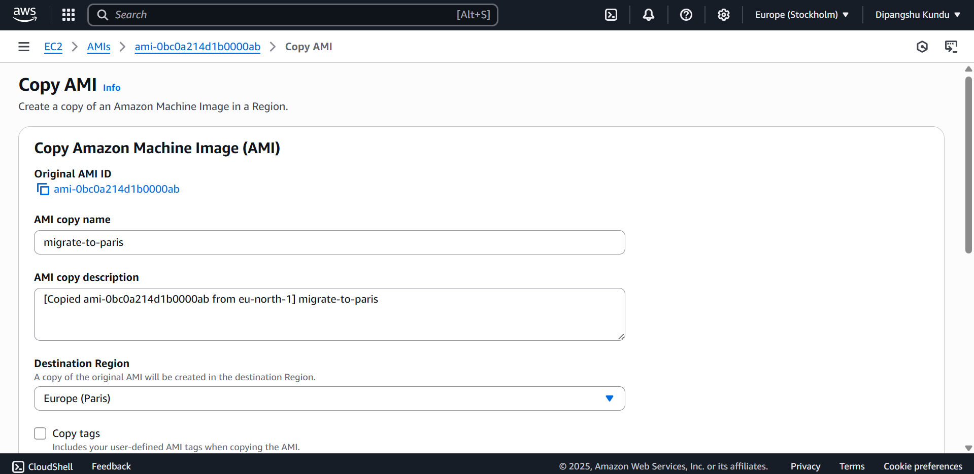

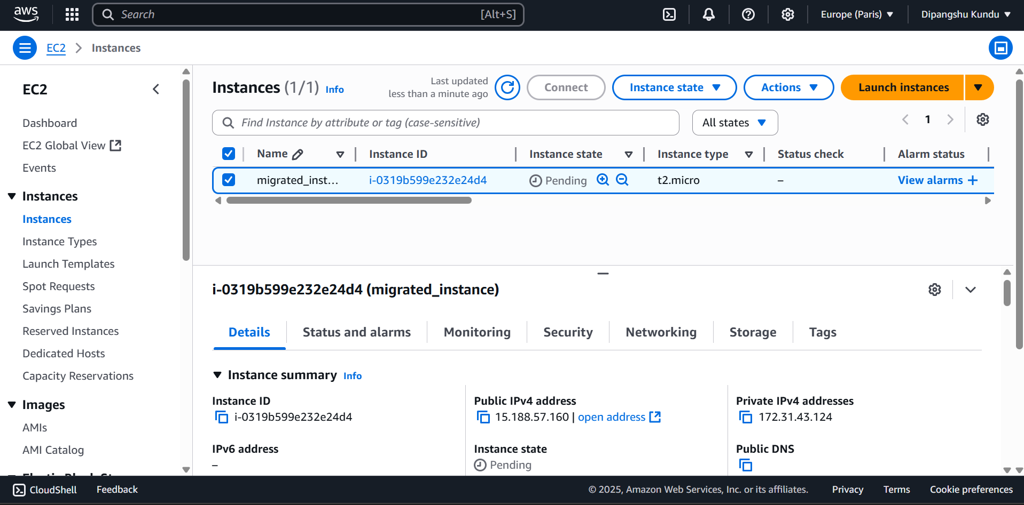

**DESTINATION REGION:**

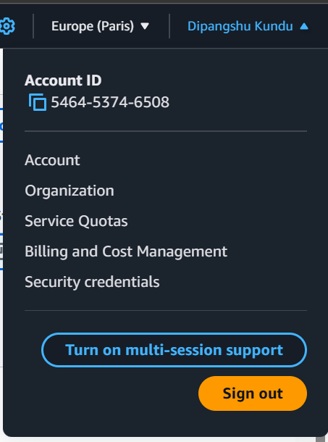

**QUESTION 2:**

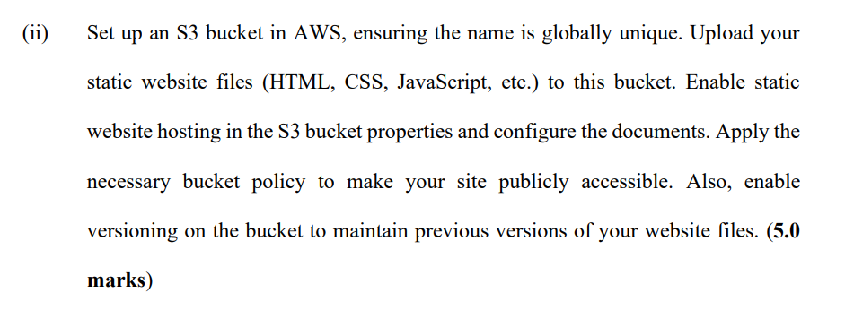

**SOLUTION: -**

**CREATING AND SETTING UP S3 BUCKET:**

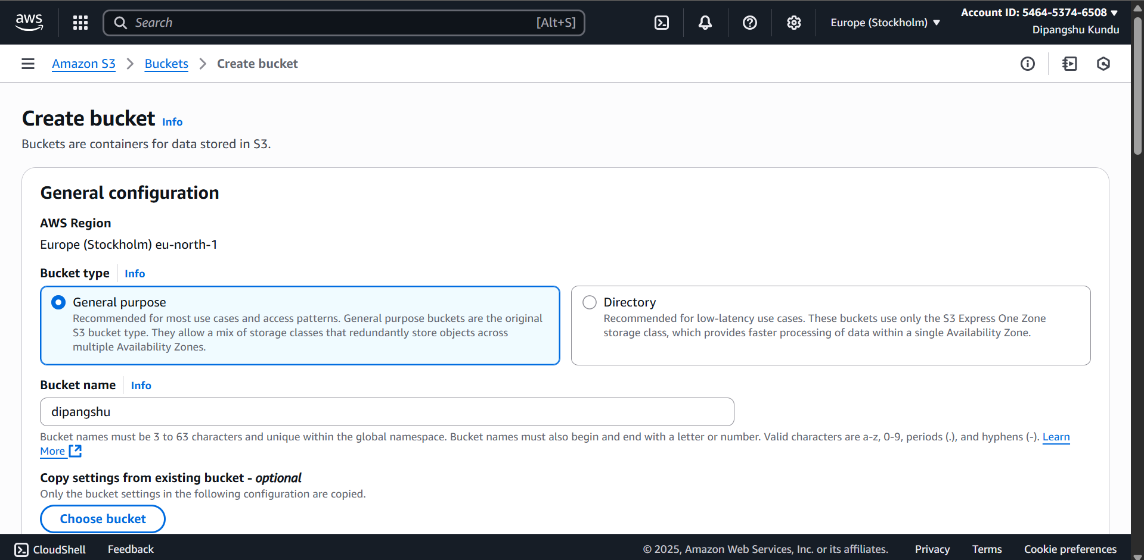

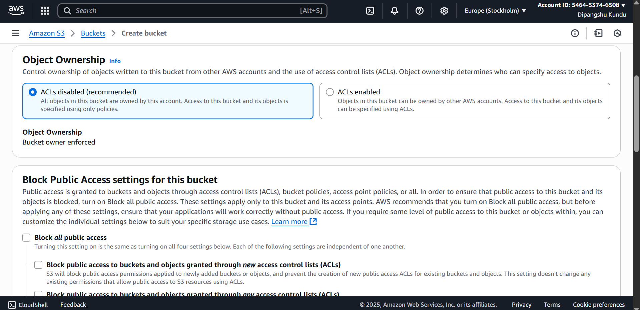

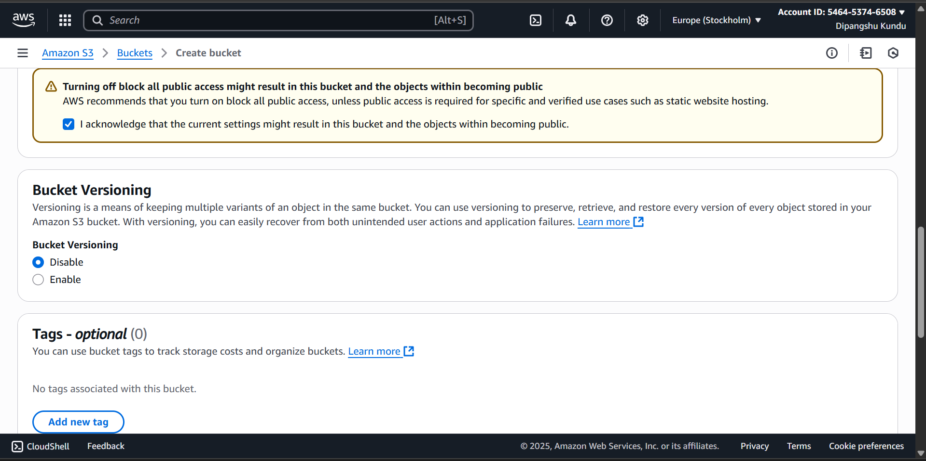

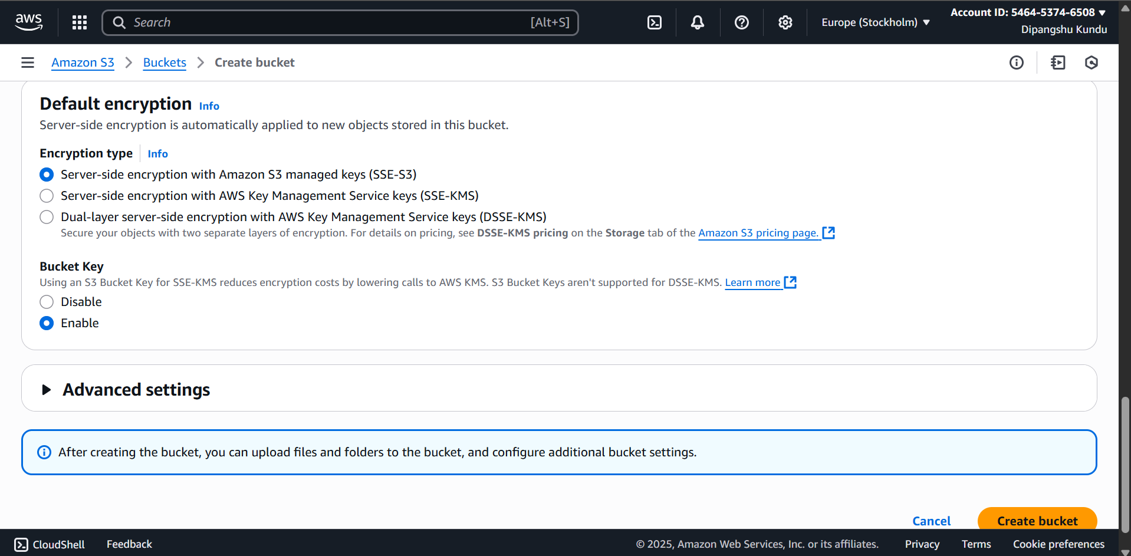

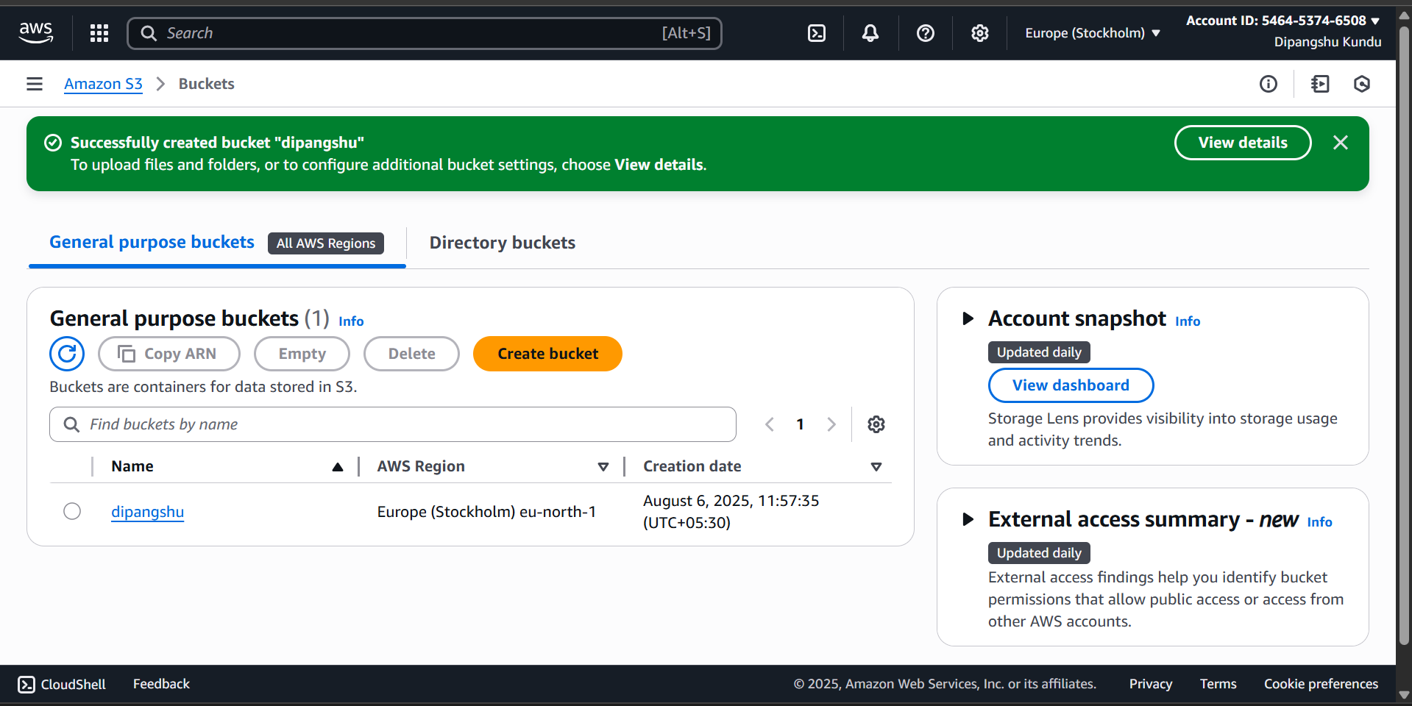

**ENABLING STATIC WEBSITE HOSTING:**

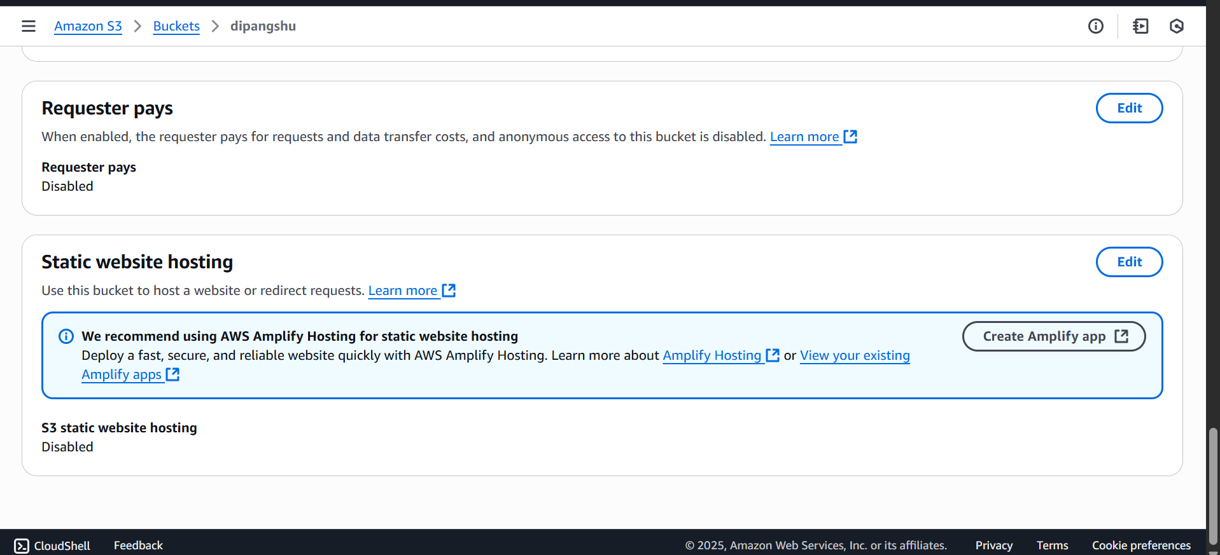

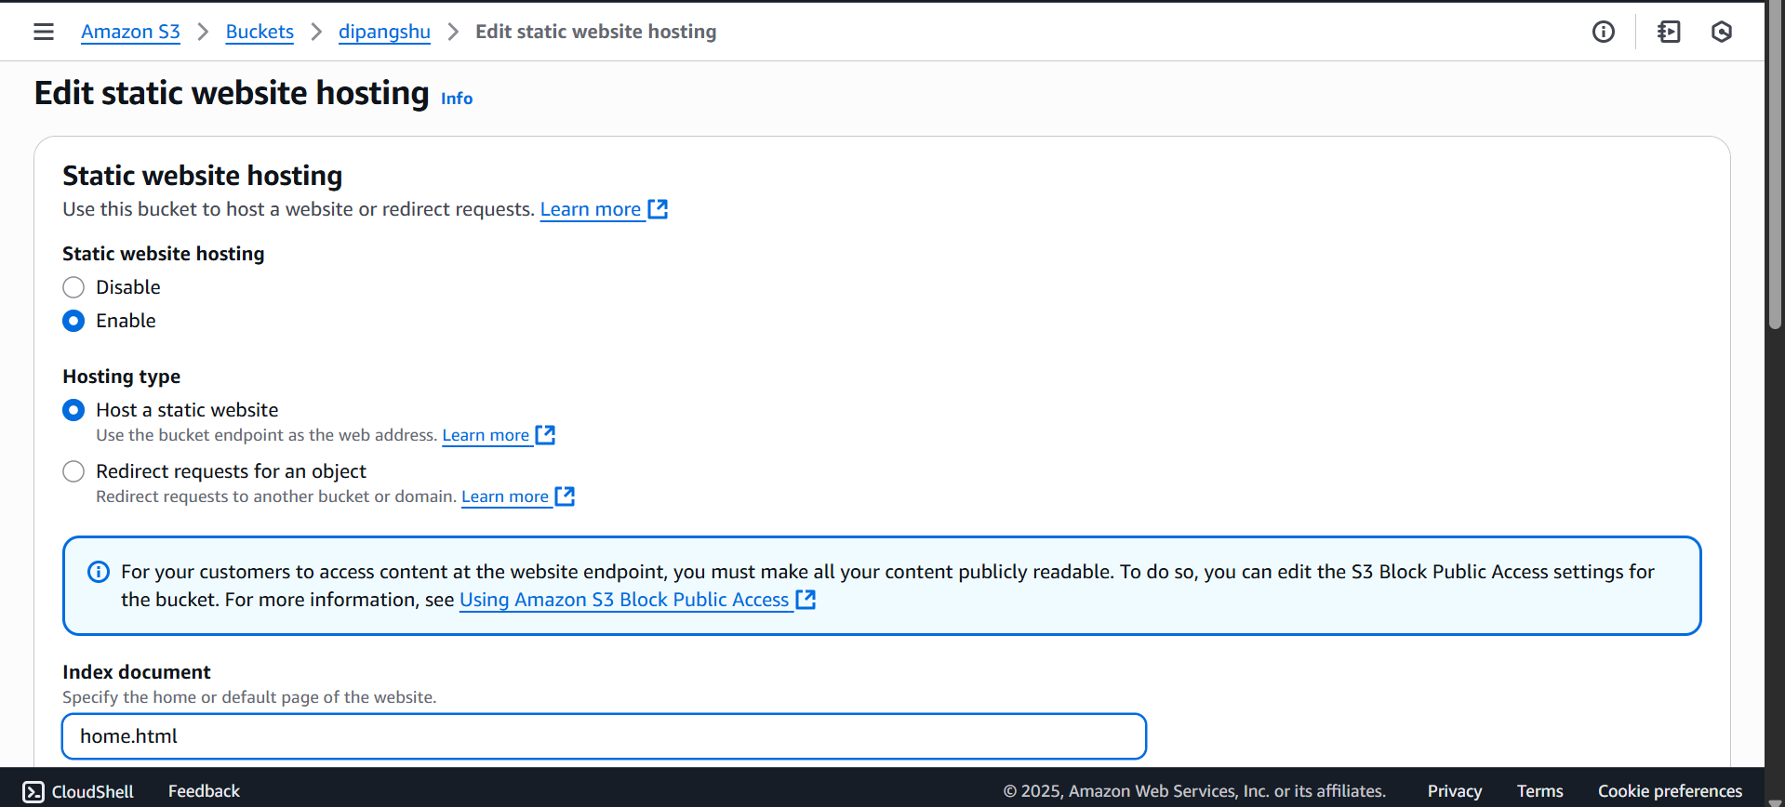

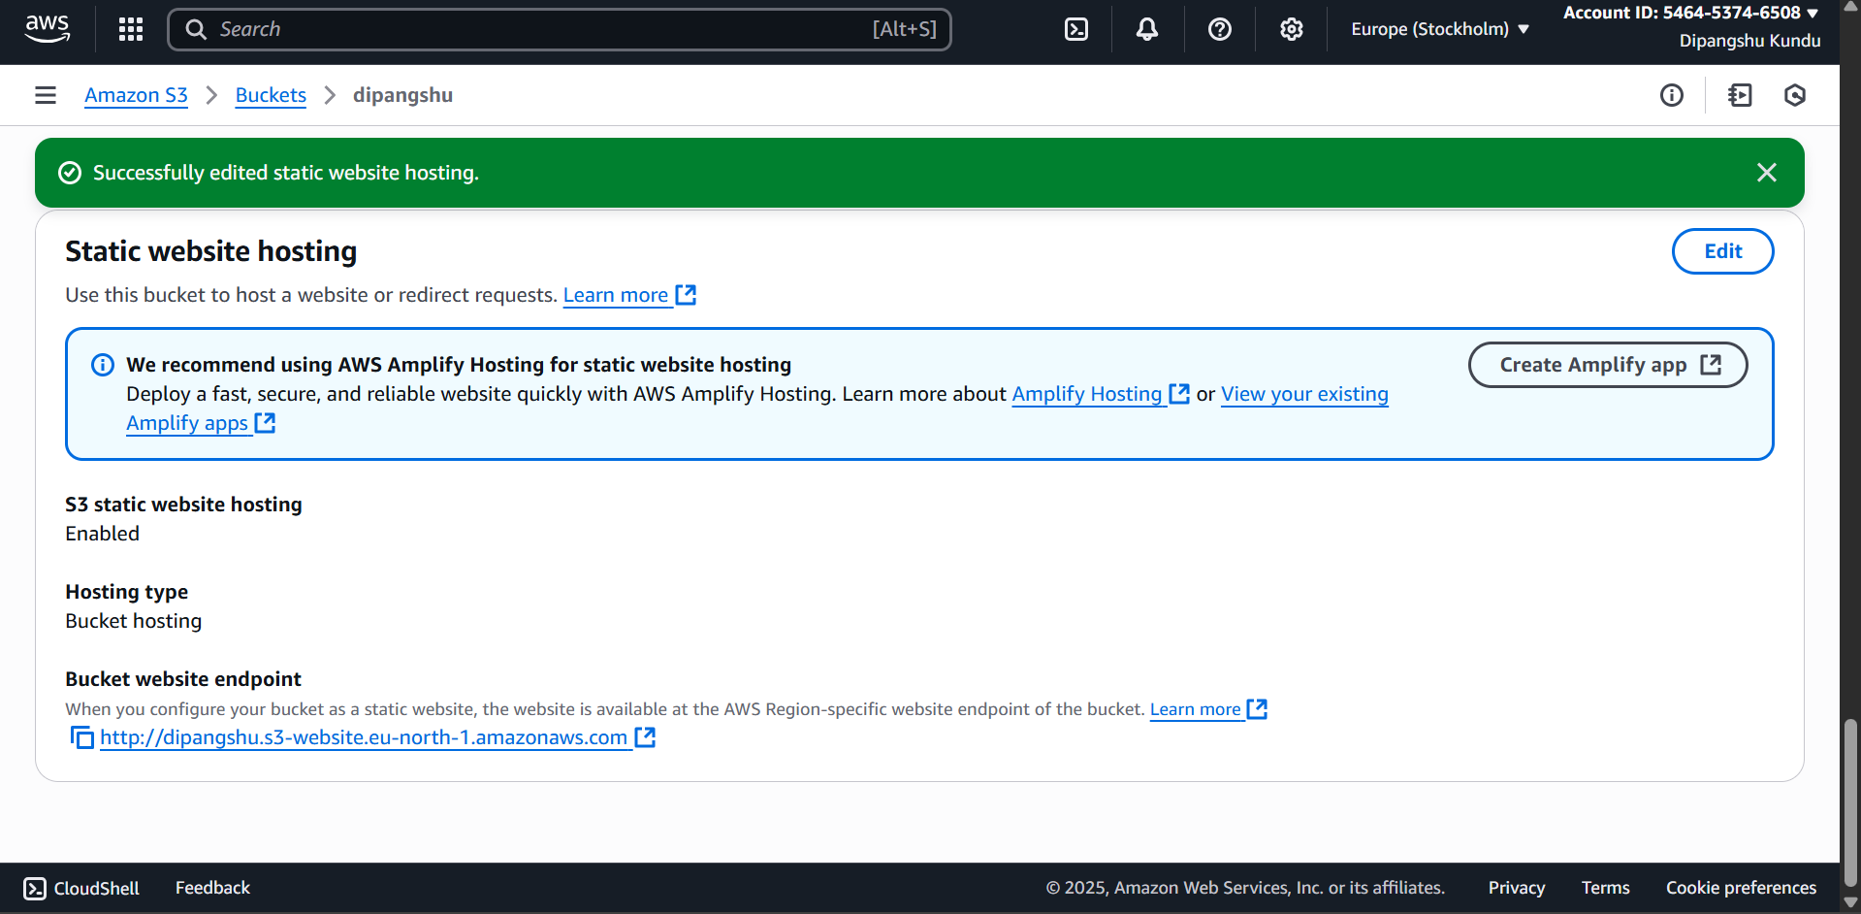

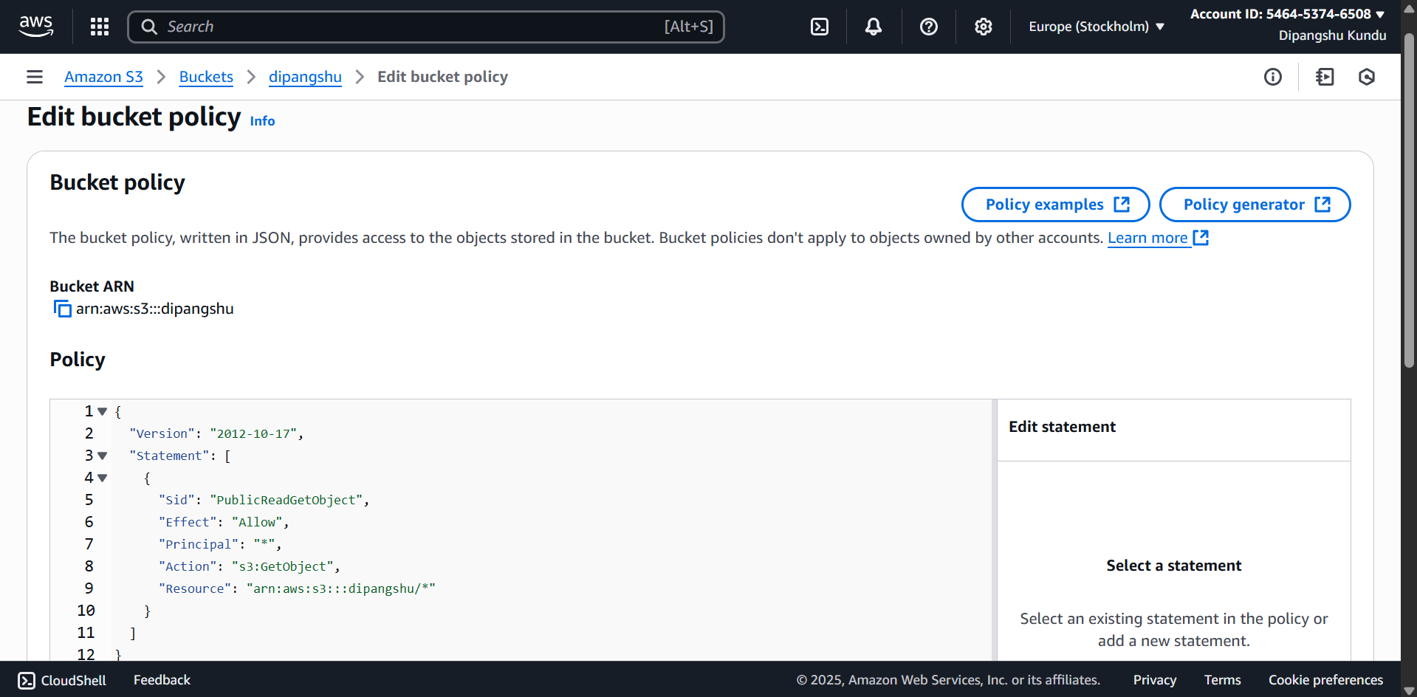

**STATIC WEBSITE’S FILES UPLOADED:**

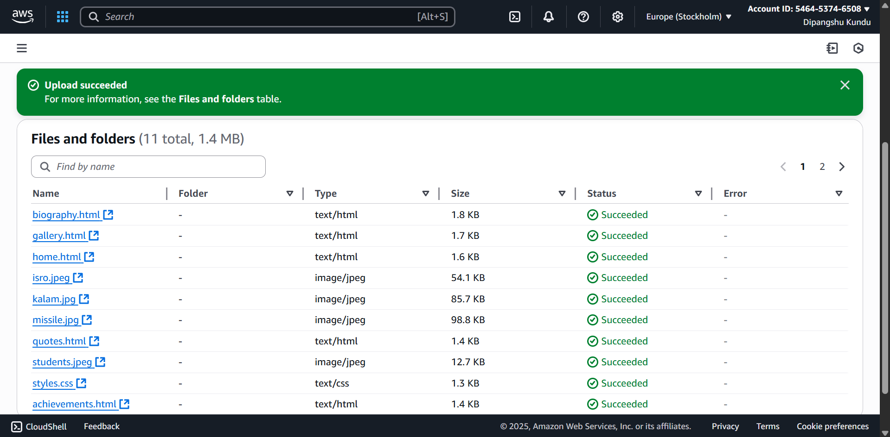

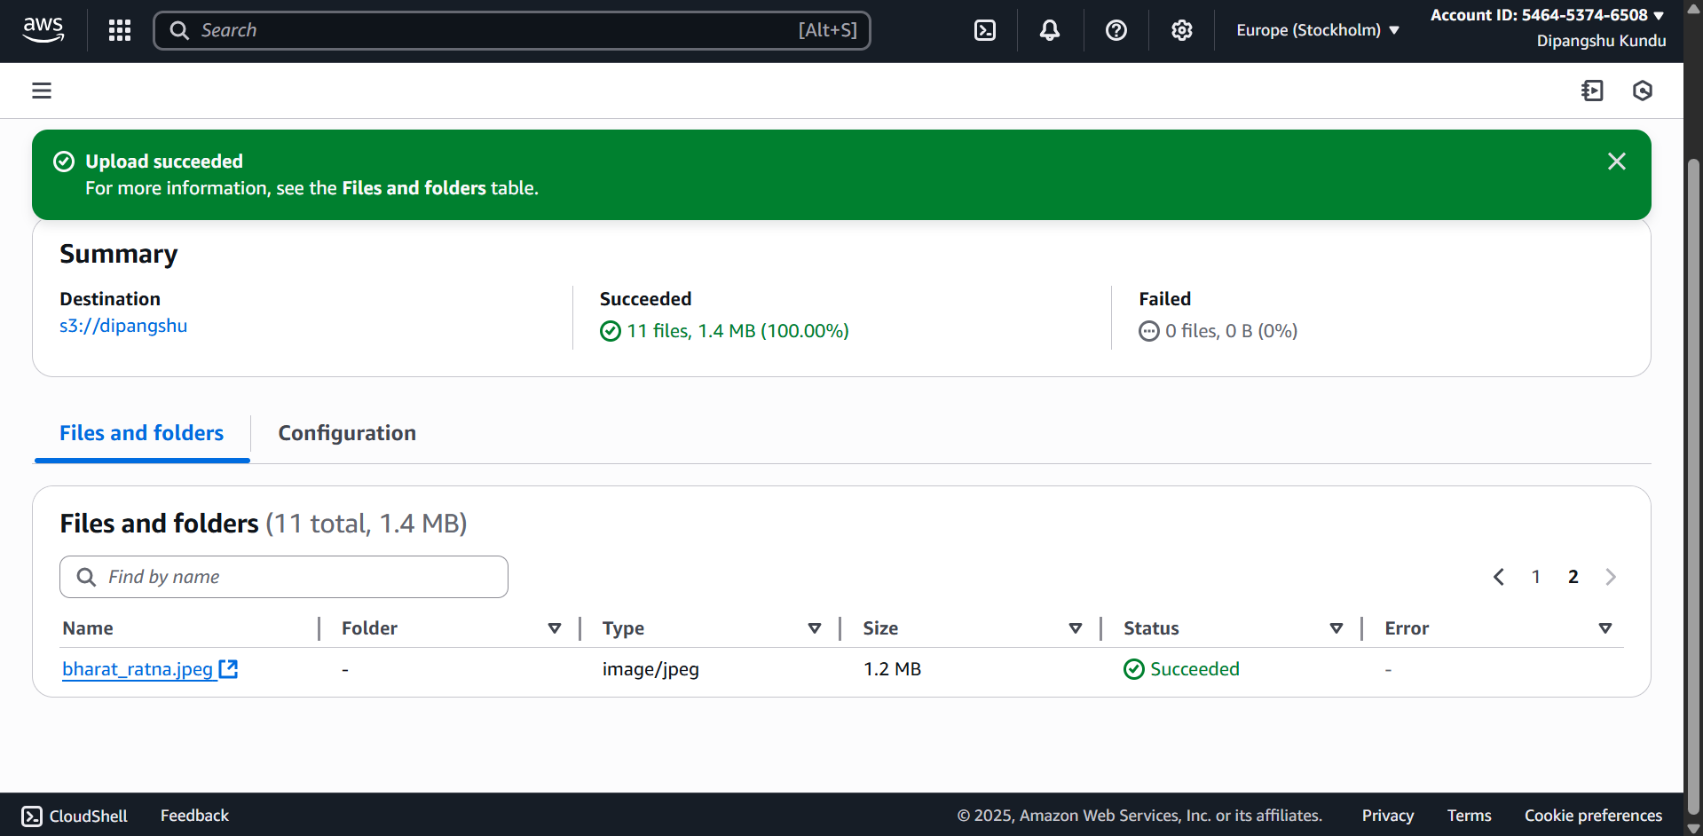

**WEBSITE HOSTED:**

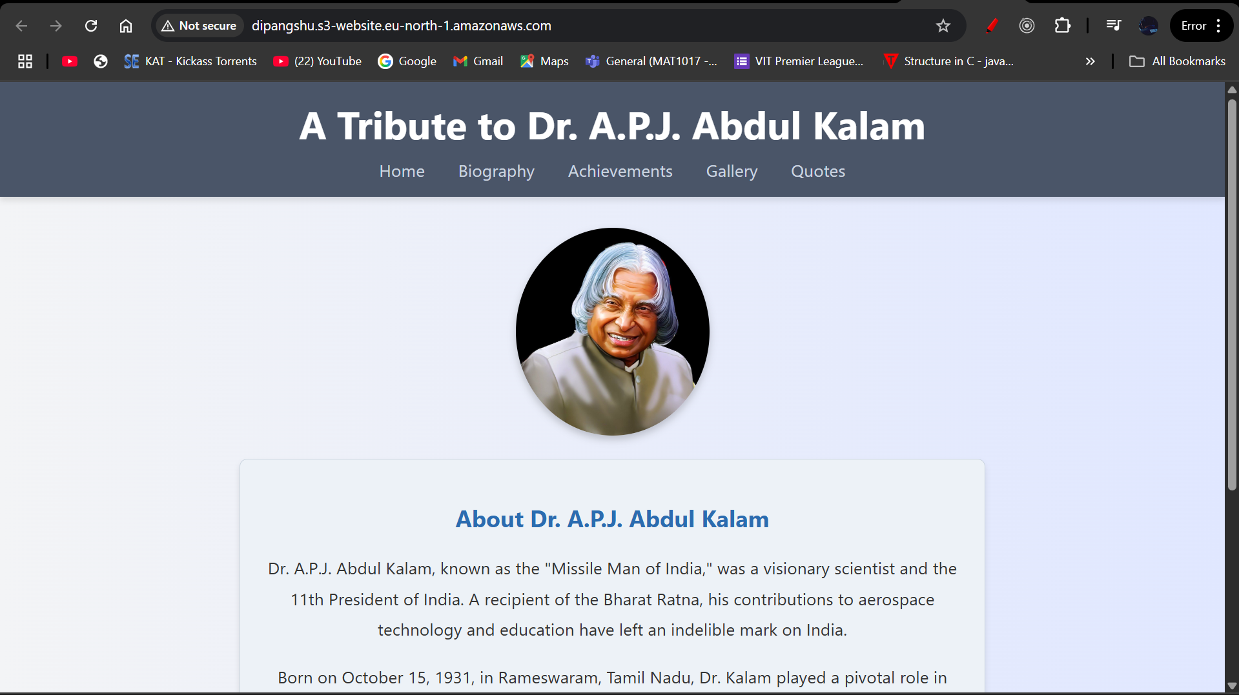

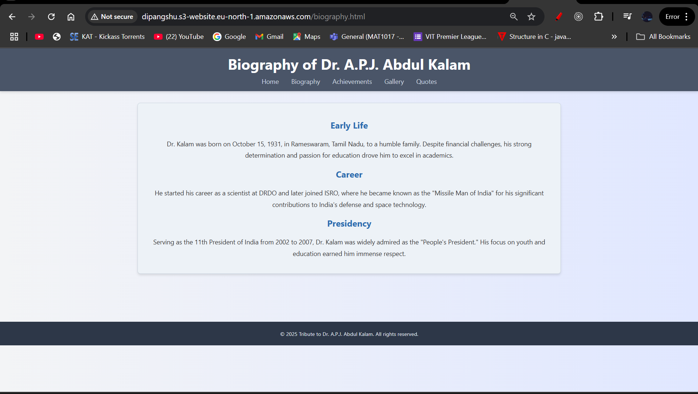

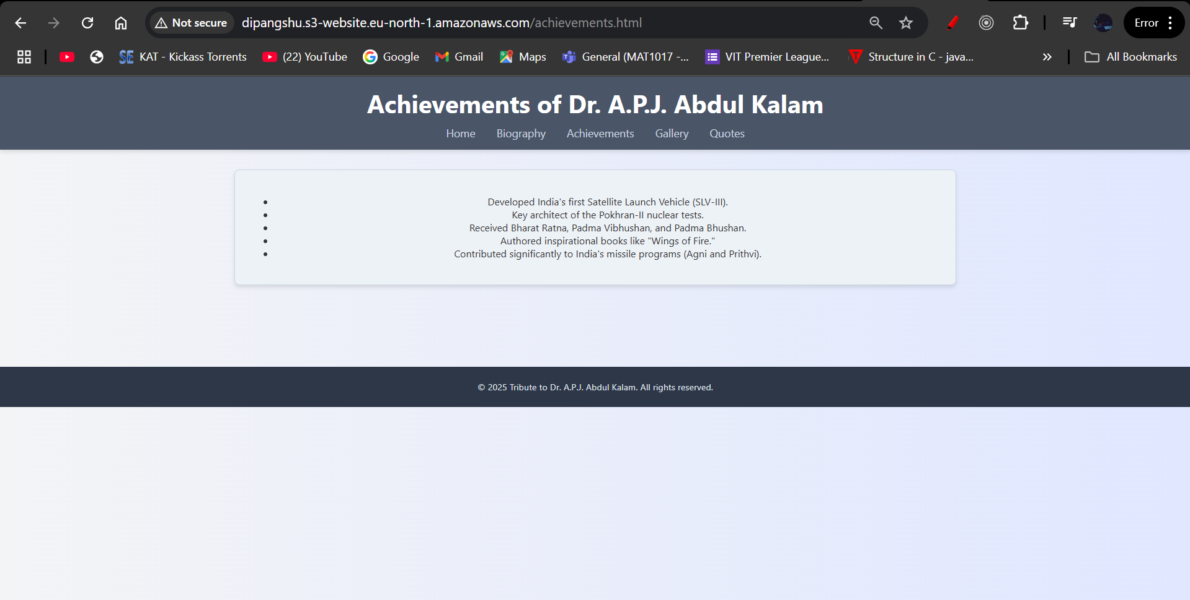

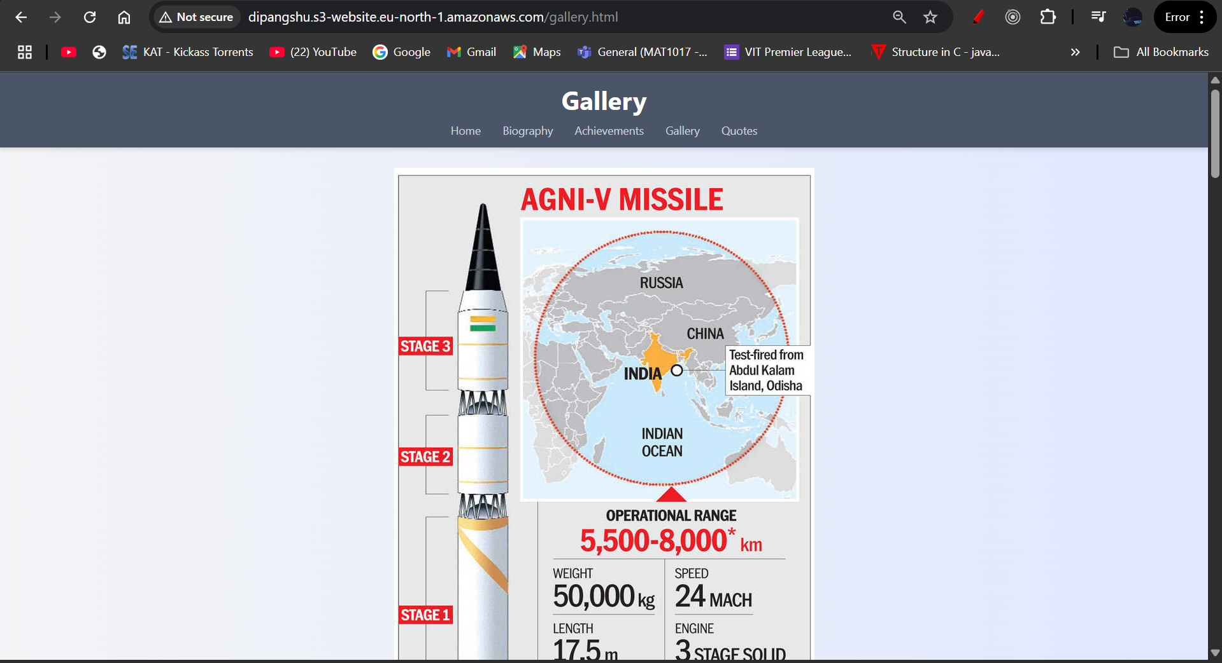

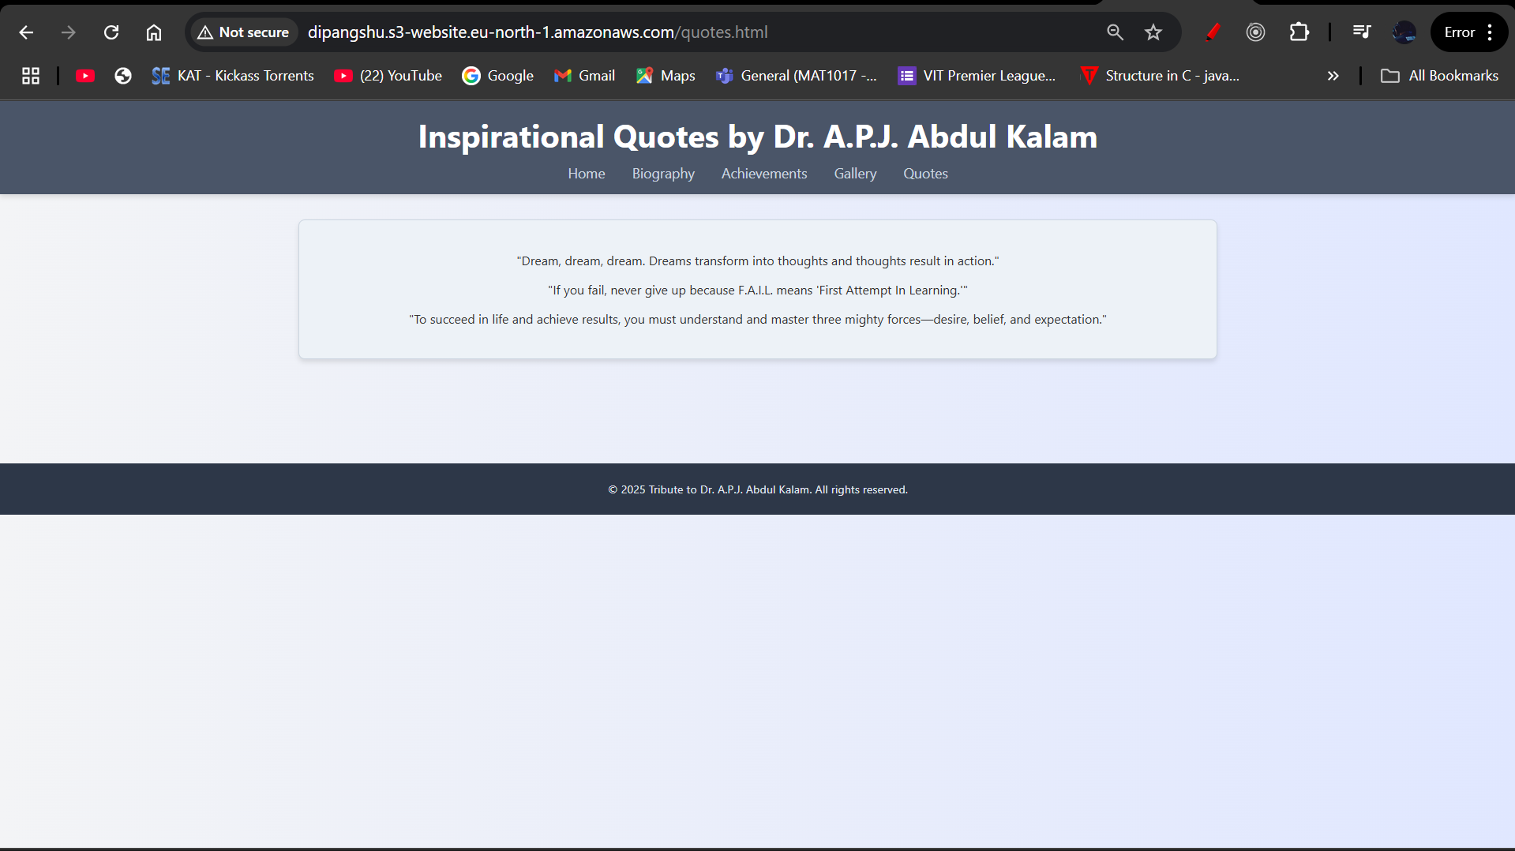

**ENABLING BUCKET VERSIONING:**

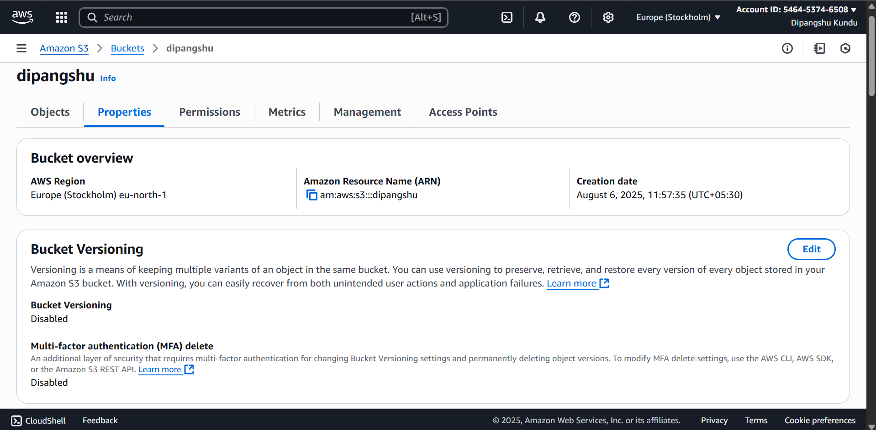

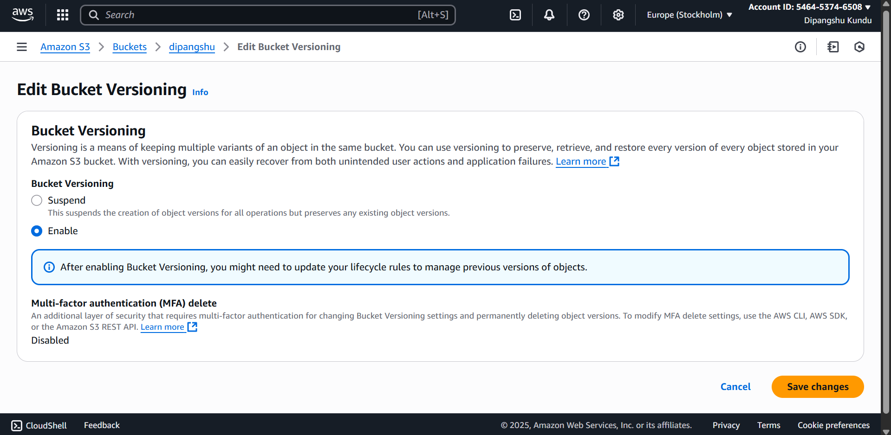

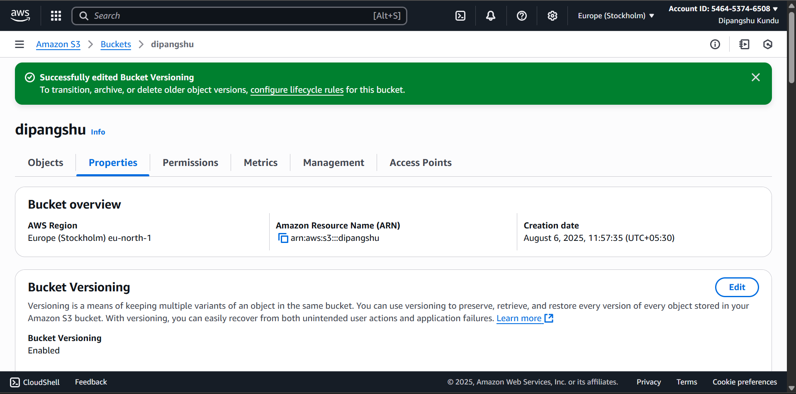

**PUBLIC ACCESS LINK:**

<http://dipangshu.s3-website.eu-north-1.amazonaws.com/>

(please open in ‘http’ not ‘https’ if by chance it opens in ‘https’)